Campus – oops

Class : blue print how object behaves

Class: data/attribute/property

Function/method/behavior

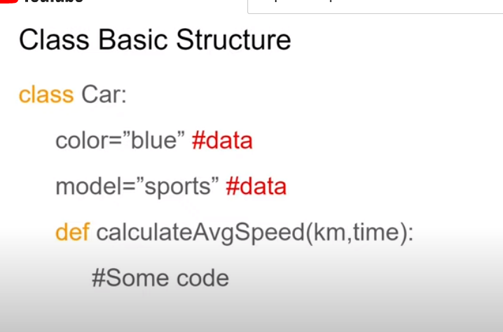

Class: pascalcase

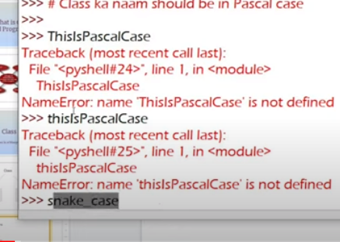

Variables and methods: snake-case

def train_test_split()

--

Class car

Attributes : metion with-

* Means private

Methods: : mention with+

Snake case

Plus: available to public ,we can use outside

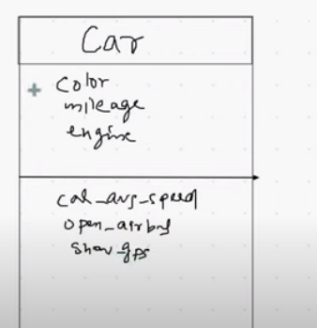

Object: instance of class

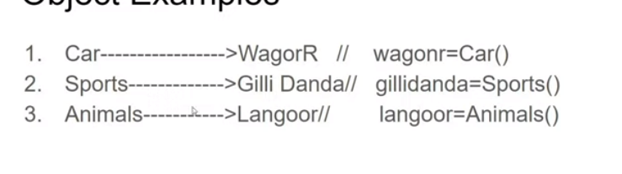

--

Diff between methods and functions

**Method:**

Function which is written inside class is called method

List.append()

**Function:**

Function is available for outside of class

Len(list)

--

--

To declare variable inside class

For to declare variable

We need to give a special method called __init__ method



Constructor(__init__)

Special method gets executed automatically when we create object of class

--

--

Xyz is file name

Atm is class



Now create object



Class Atm has method

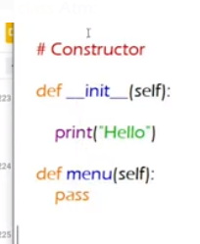

When we create object it automatically init execute

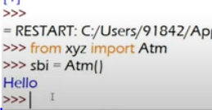

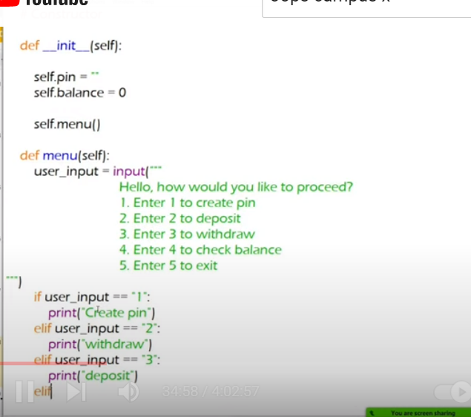



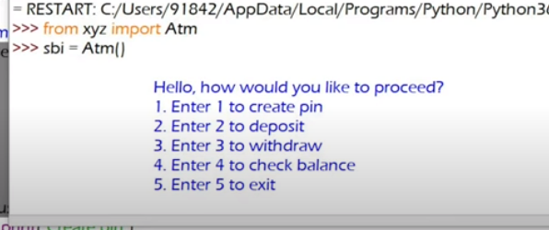

Now third method



Now for every condition one one func will be created

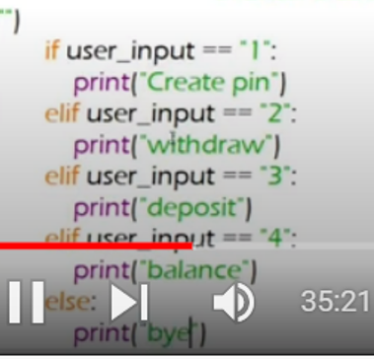



Deposit function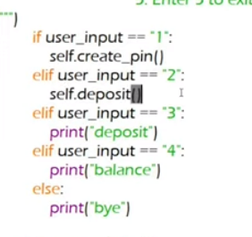

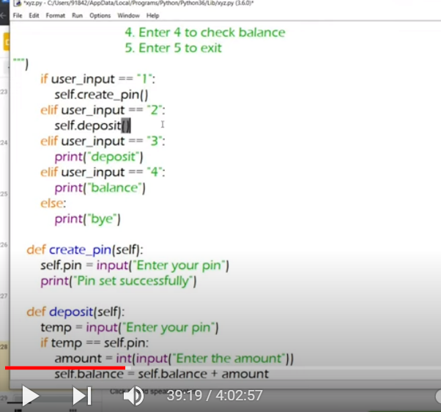





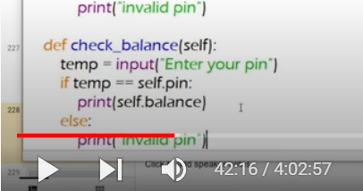



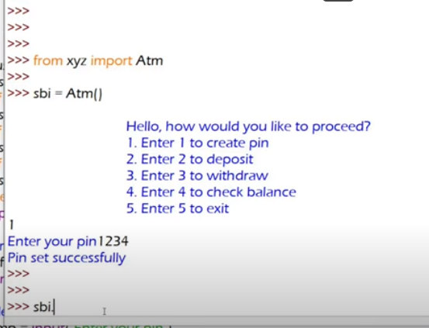





Diff balance for hdfc , sbi

It creates diff pins

Diff balance

All are diff

--

--

Constructor: special method or magic method

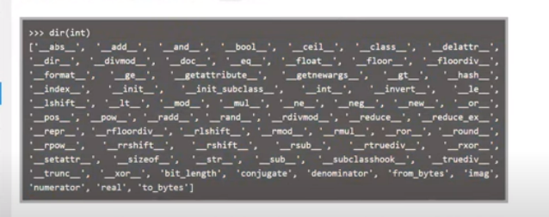

Before and after double underscore

Magic methods are predefined

These methods not required to call though object like(Sbi.balance_check)

It automatically triggers

Constructor is one of magic method

Whenever we create objects gets automatically executed

Actual atm> we have calls for diff methods like withdraw, balance check

But constructor is not in hands of user

**What is use of constructor?**

Configuration related task

Our database connection

Which helps in running app

--

Self:

The methods can be accessed by objects so self inside methods

One method cant access other method

Method can only accessed by objects

so for accessing one method in another method we should use self

self.method()



Here self.menu() is method inside another init method

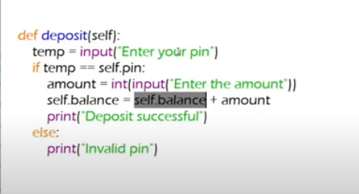

Even data within one method cant access in another method, to access we must use self.a

--

Data and method can be accessed by objects only

How can we create our own datatype(fractions):

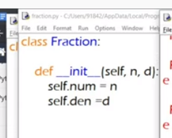



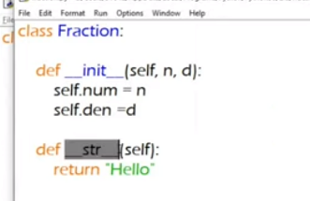



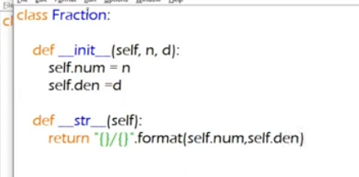

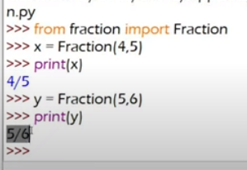

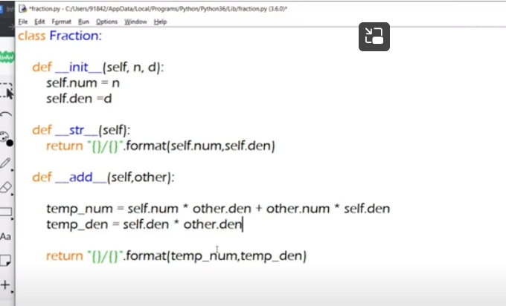

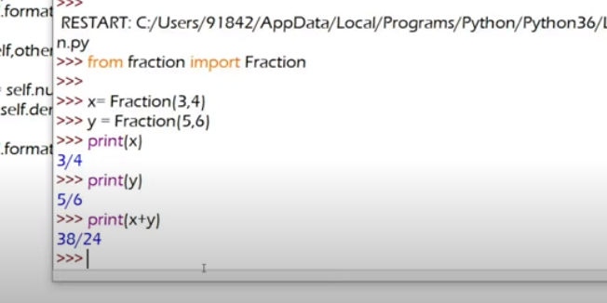

--

**Instance variables:**

Instance variables which are inside constructor

Pin and balance

Variables values are different for diff object

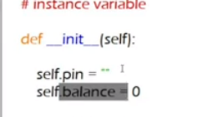

Value of variable diff for diff objects

When we create object we can access variable and methods of class

Its not good to open code like above

That may be spoiled by junior programmer

I should hide data

We keep __ beside variable

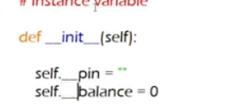

So we cant access them outside of method

Wherever we are using these variables inside methods should be replaced with__



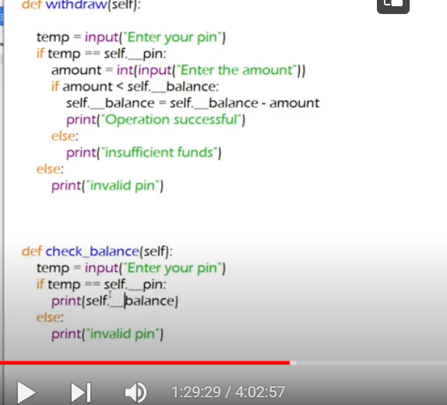

By using__ we can hide any method also



Here __init__ cant be seen in methods

Even we can hide any method by using ___



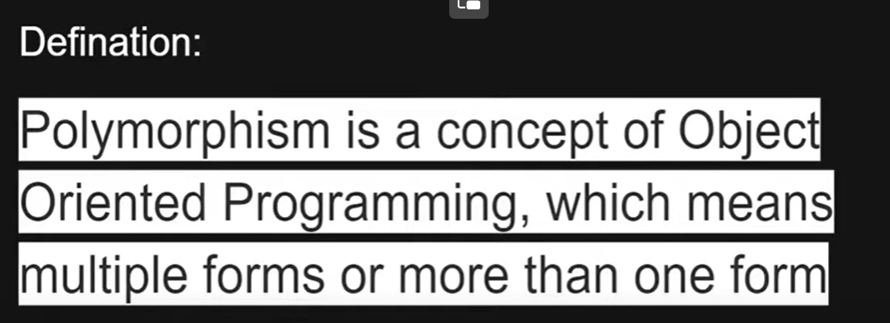

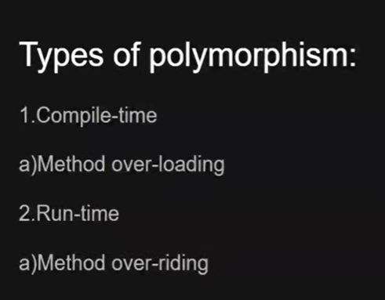



Method overloading:

In same class same methods with diff parameters

**Overriding**: diff classes, same function name with different parameters

overloading

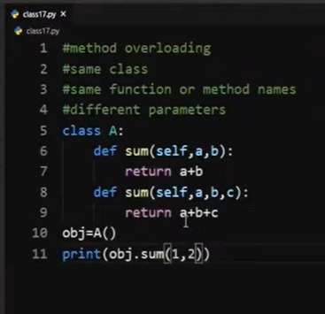

Error comes

Because it takes below functions

How to overcome?

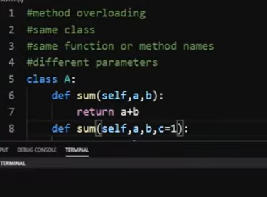

We need to give default argument

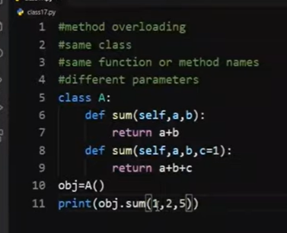

1 place lo 5

Same function can handle diff parameters by using default parameters – method overloading

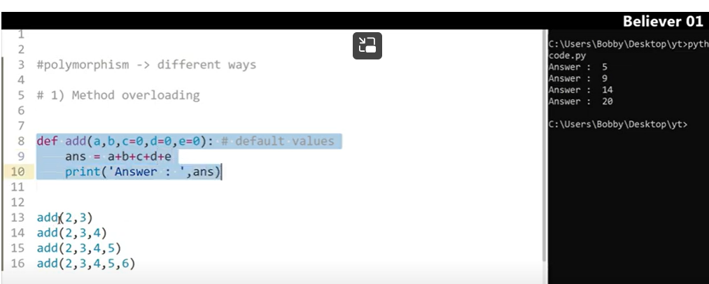

Method overriding:

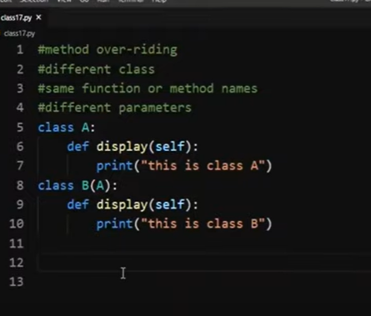

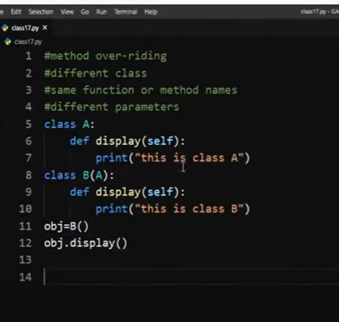

When we execute class b only gets executed

When we want to get Class a display function

We must use super

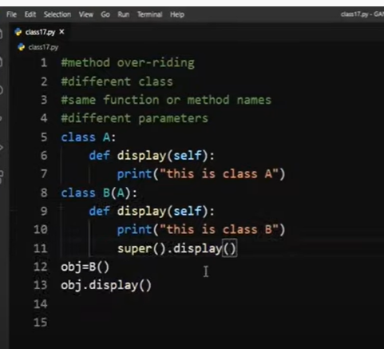

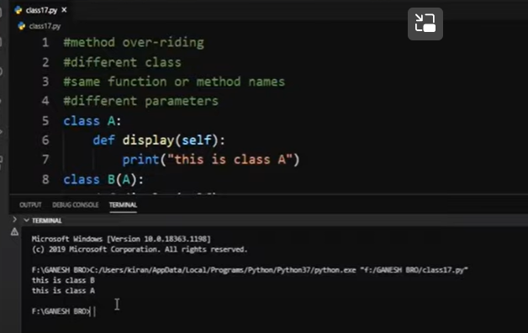

Super keyword; to overcome method overriding

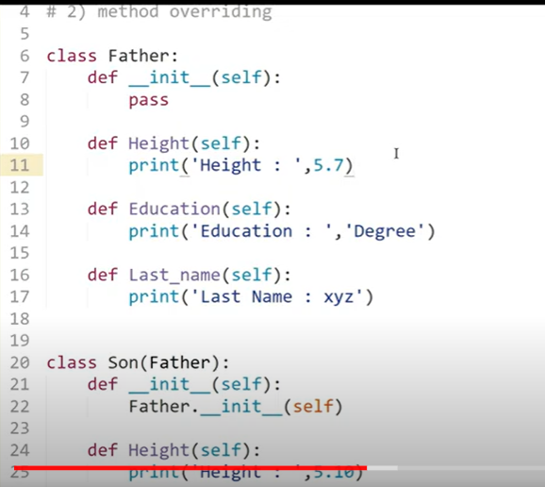

Diff class same function name under inheritance

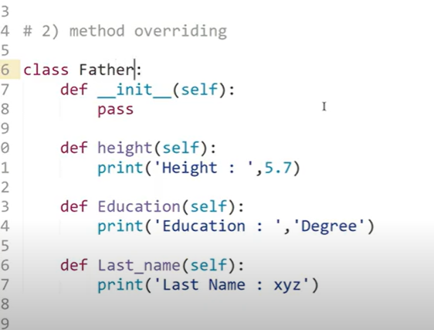

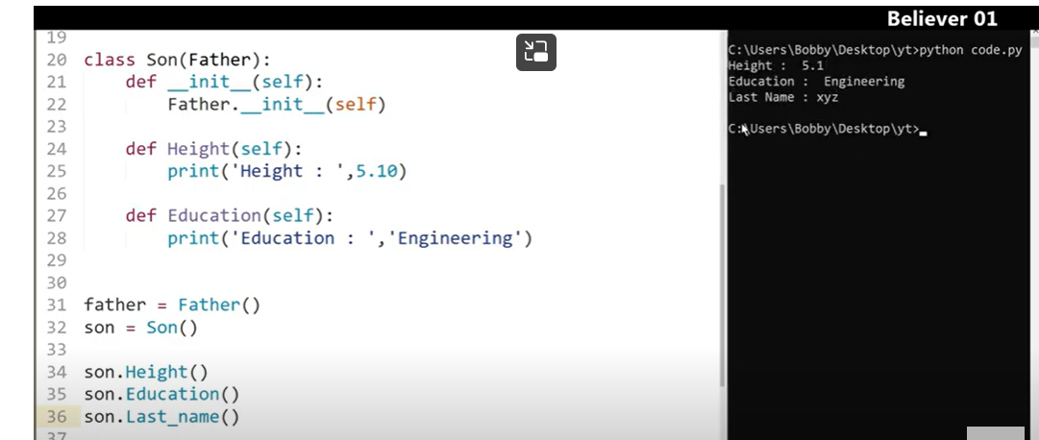

Method overriding we can use same methods in child class and change data as per the interests

Method overriding means we can change the method nature of base case in child class when we use same function name.

For example

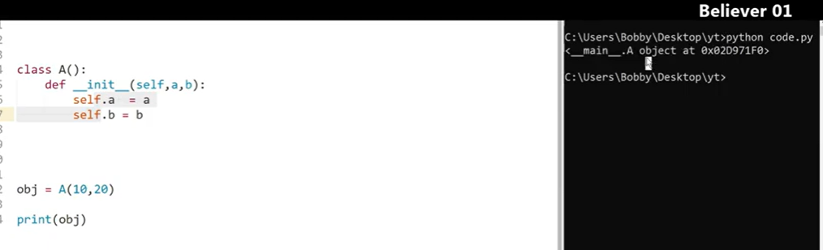

When we print obj we will get only memory add

But when we want object data should be print

We all know that every class we create in python derive from object class

Object class has a method __str__ which returns object values

We can override this method of object class to our class to print obj vales

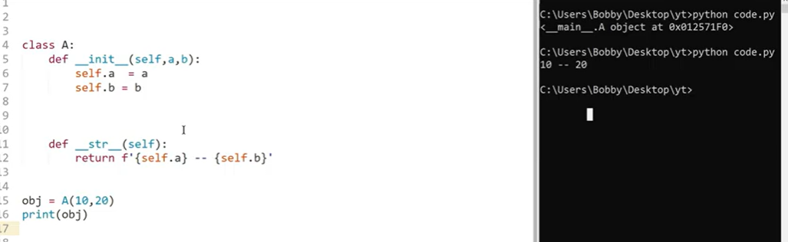

This is called method overriding

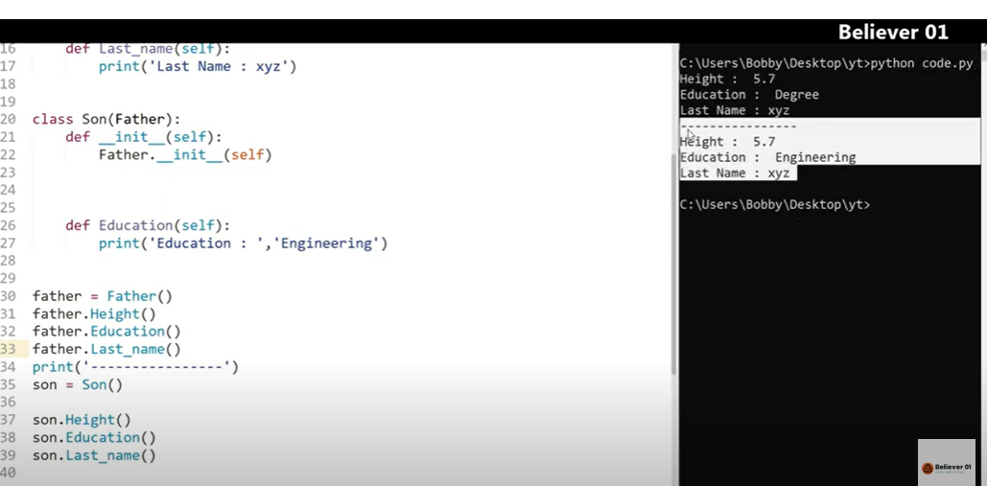

Operator overloading:

2 numbers – compiler knows what to do(what operations must do)

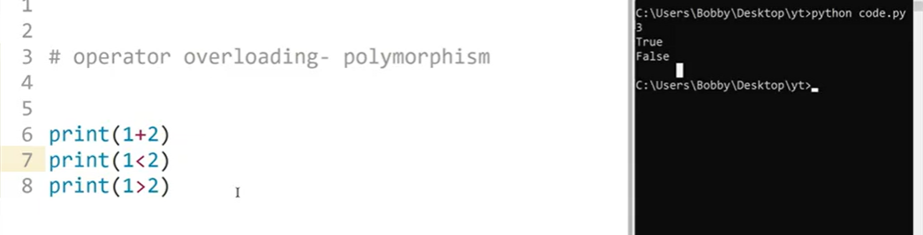

Compiler doesn’t know what to do between 2 object(what operations should be done)

Operations ki Madhya emi operations cheyyalo compiler ki telidu

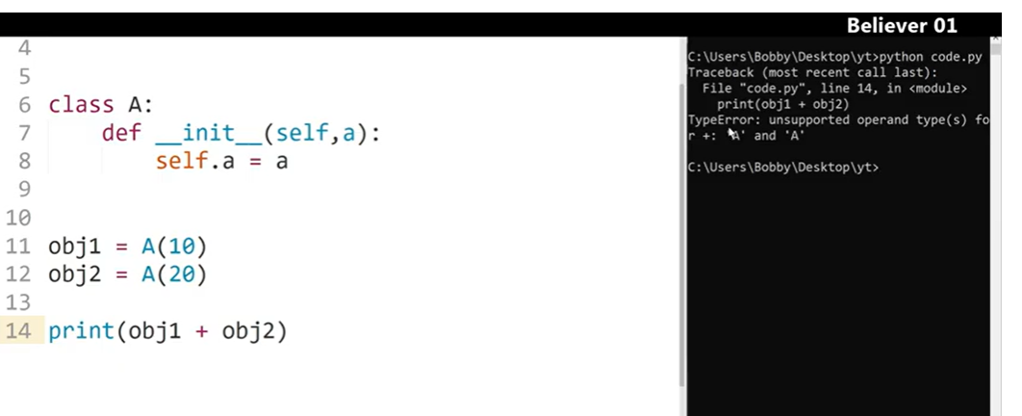

Error vastundi

We have diff operators

(every class we create is a sub class of Object class in python)

Object class as diff functionalities

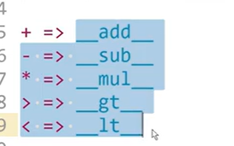

We need to override these functions as per our class (because these belongs to main object function and our class belongs to this main object class)

We can override like this

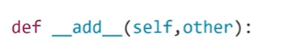



Left (obj1)– self

Other -obj2

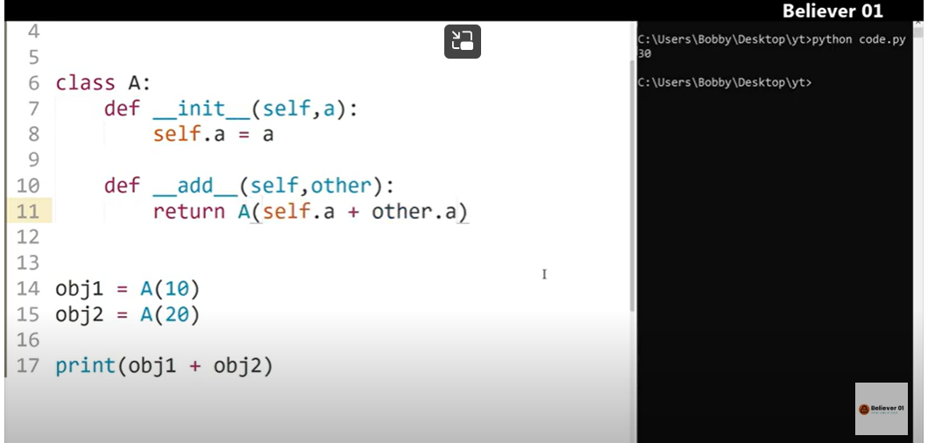

Like above we have modified add func

Or

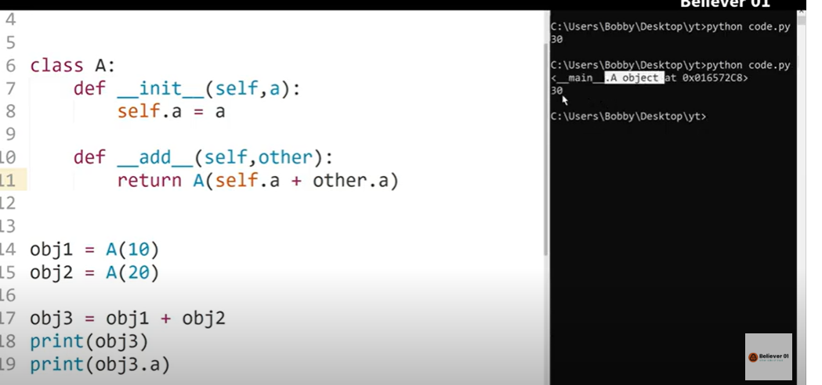

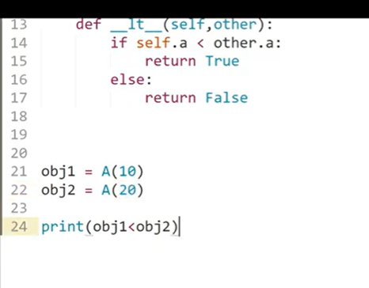

Like this we can do overloading of operations between 2 objects

Abstraction: hiding of data

It shows output

Hide functionality

Encapsulation: binding of data members and its functions

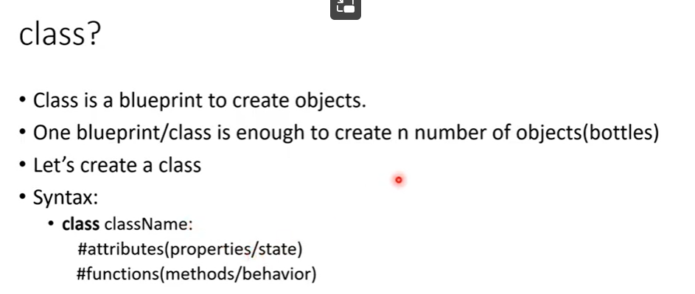

Even we can write doc string inside class : it tells whats that class for



Now we can create n number of objects(reusability of code)

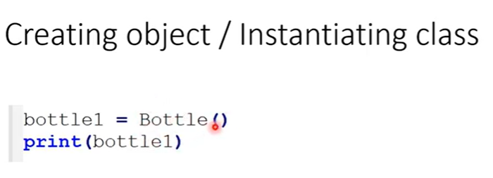

When we create object : it creates a object in memory location, gives id of location

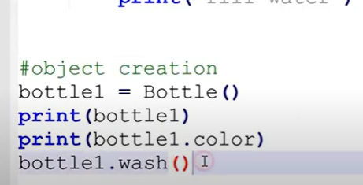

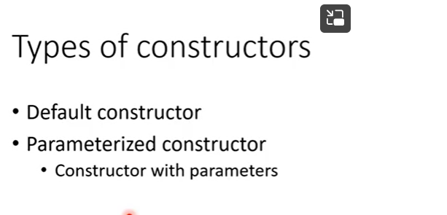

If constructor has only self as parameter is – default constructor

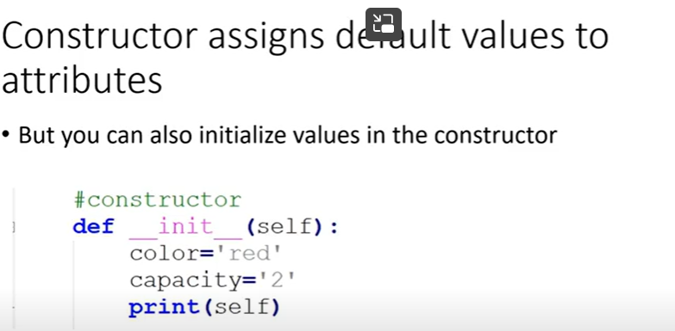

If constructor has other parameters along with default -parameterized

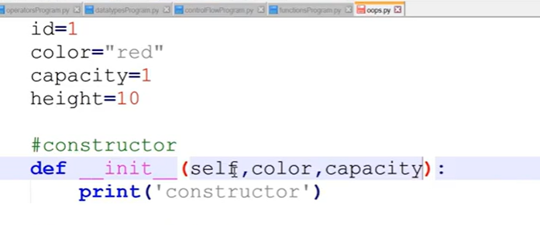

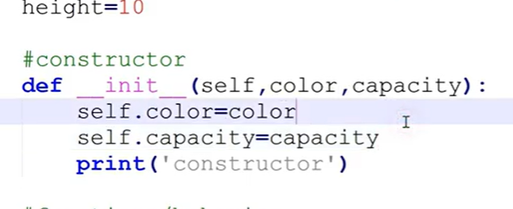

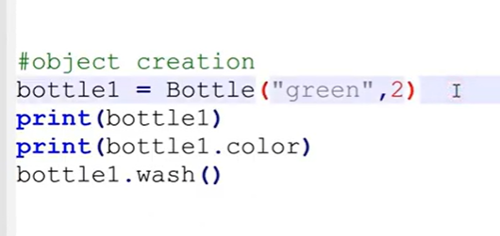

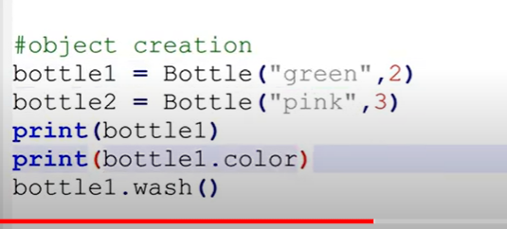

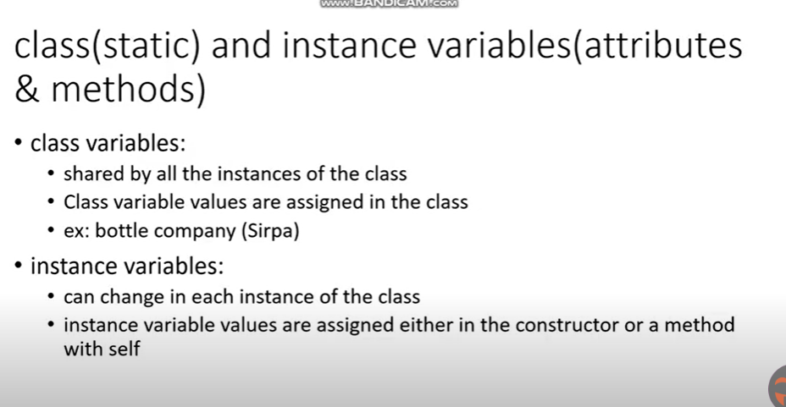

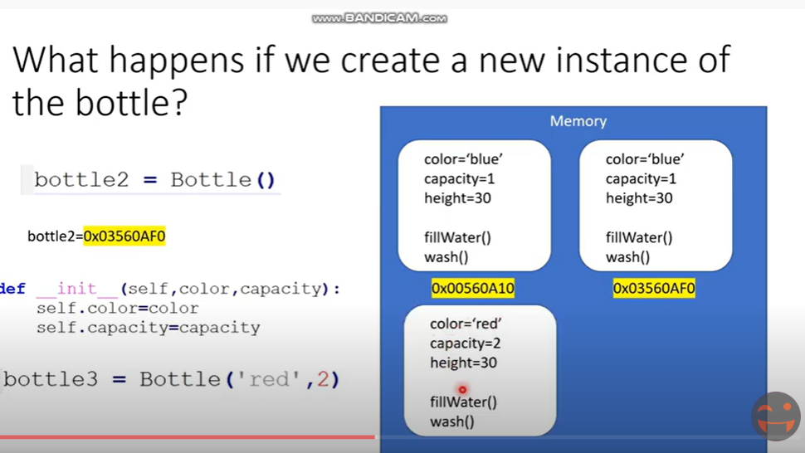

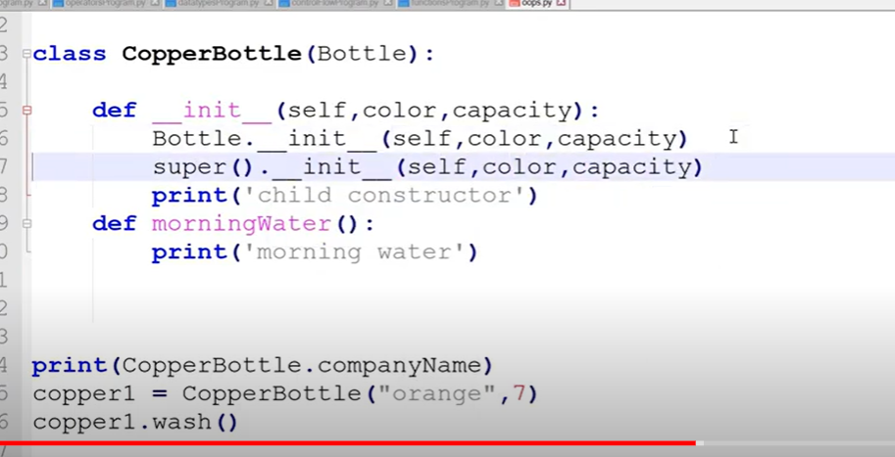

Super : no need to use self

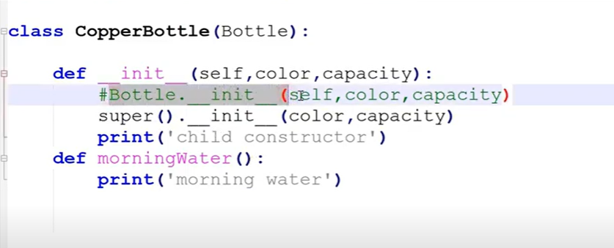







One underscore

We cant access outside class





2 underscores

Can access within class

We cant in child class

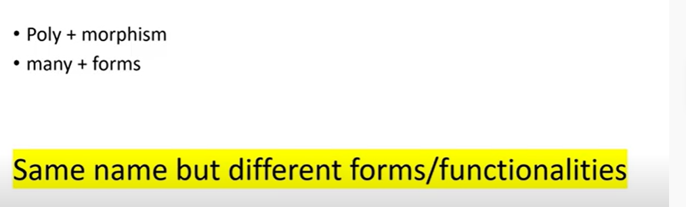

Our methods are same form but different functionalities

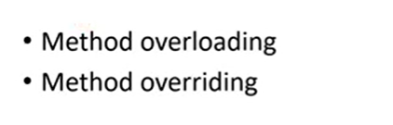



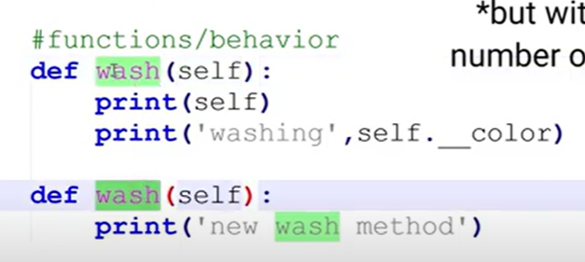

We don’t have method overloading in python

We cant create same method within class

We can write *args for sending diff arguments

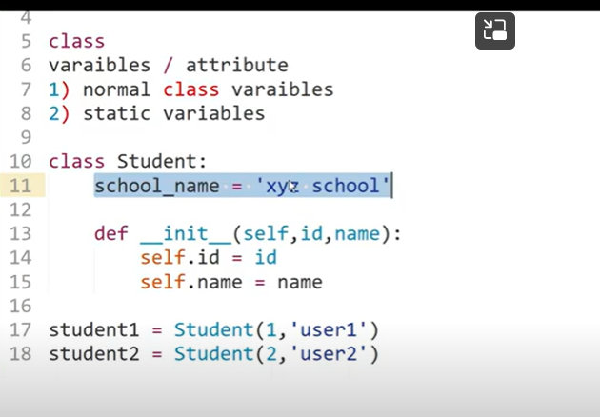

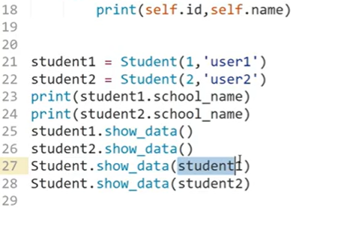

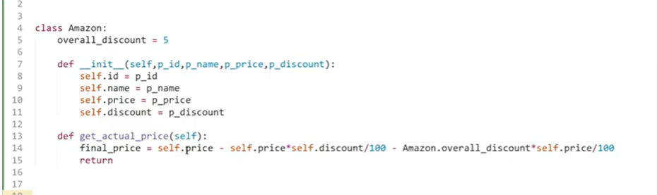



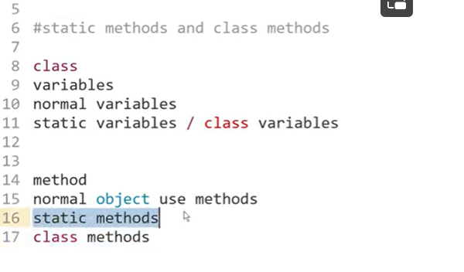

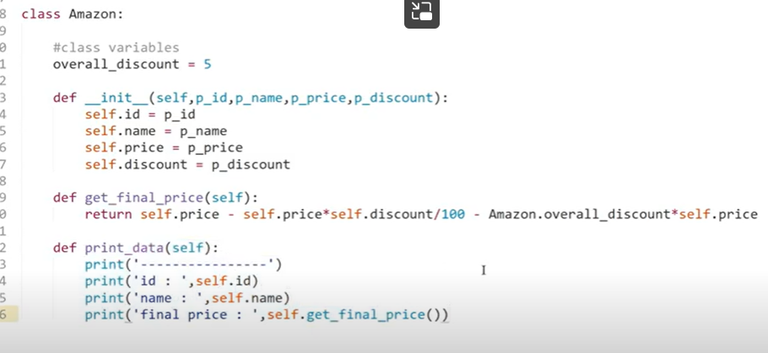



Class method: any method works on class variables

Example





Static method



It wont use class variable and object variables

It can be called with both class name and object name

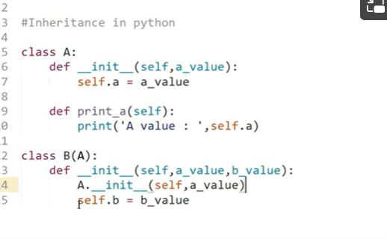

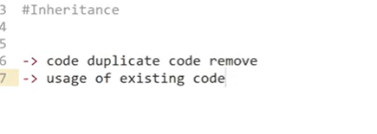

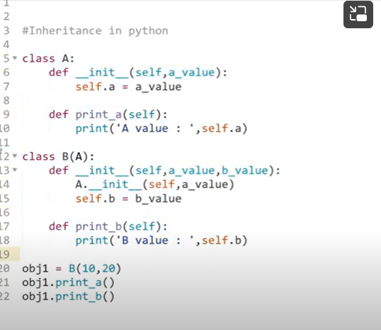

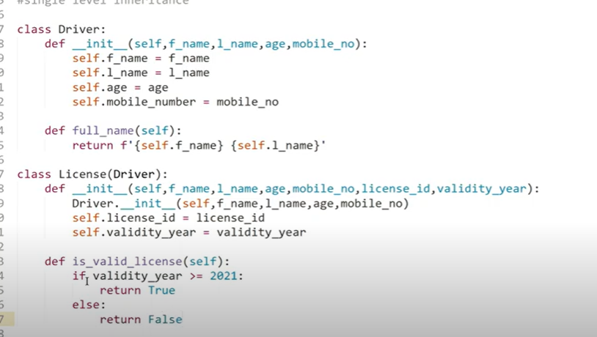

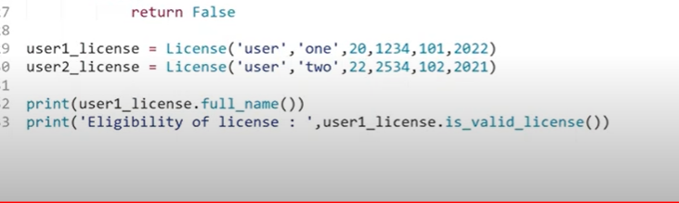



If self.validity

Multi level inheritance

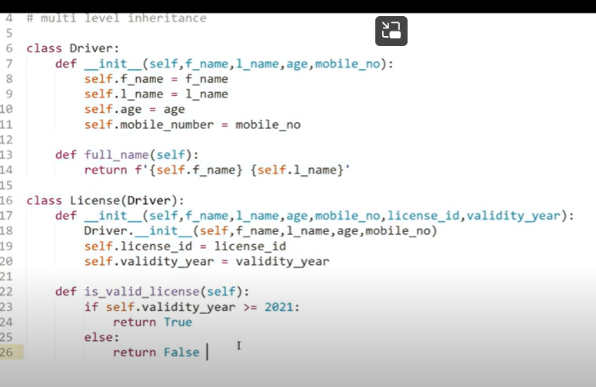



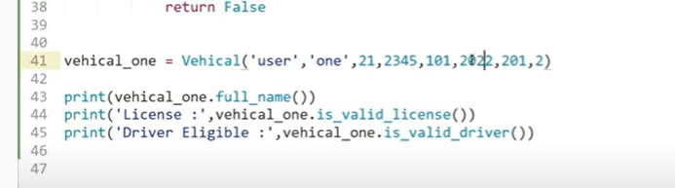

**Multiple Inheritance in python in Telugu**

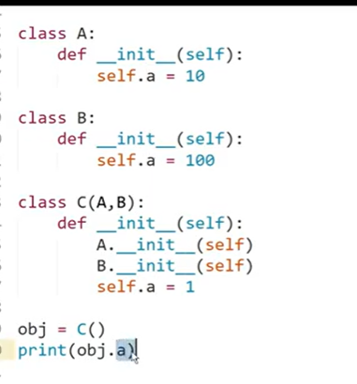

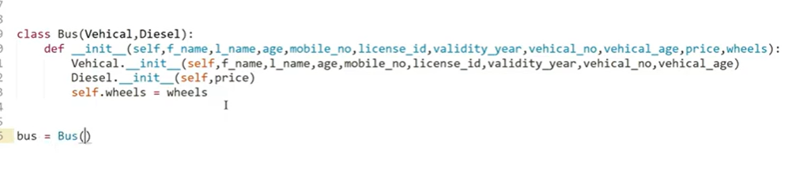

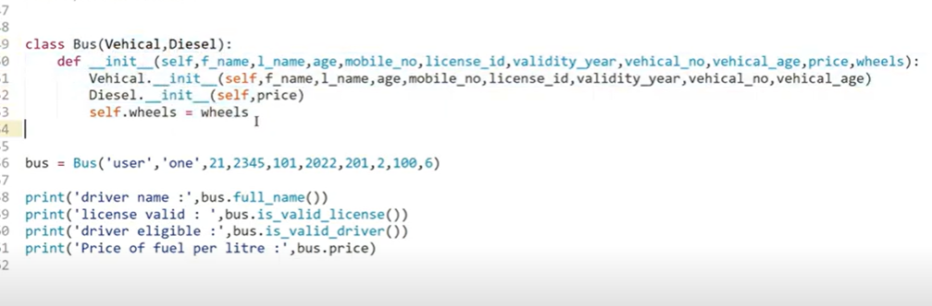

**Heirarchical & Hybrid Inheritance in python i**

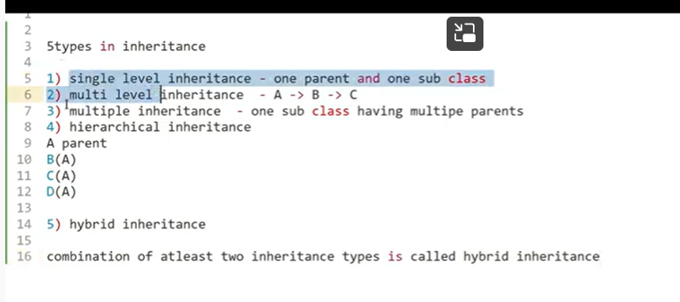





Hybrid : combination of atleast 2 inheritance

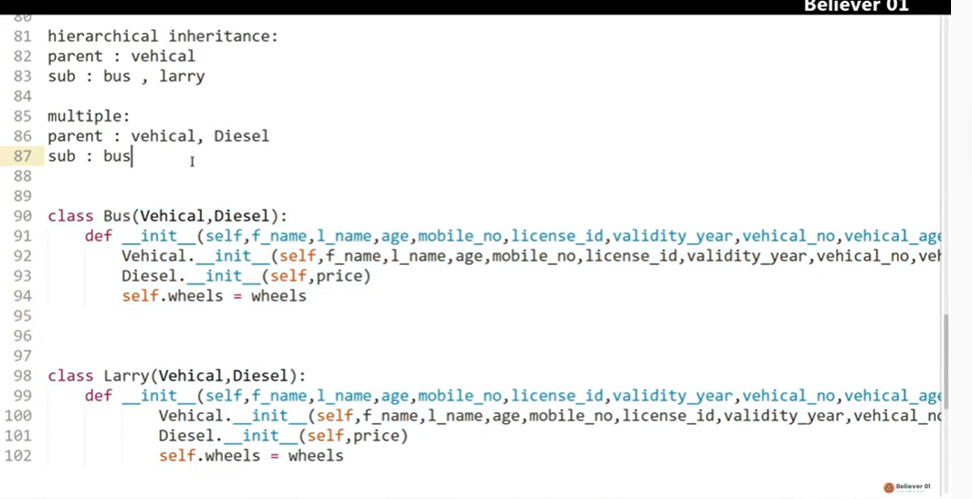

**Polymorphism in python**

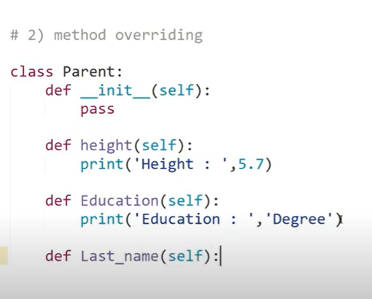

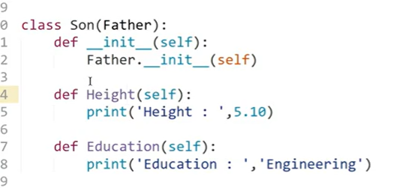

Same function …..

Parents class lo same methods can be override by using same method in child class

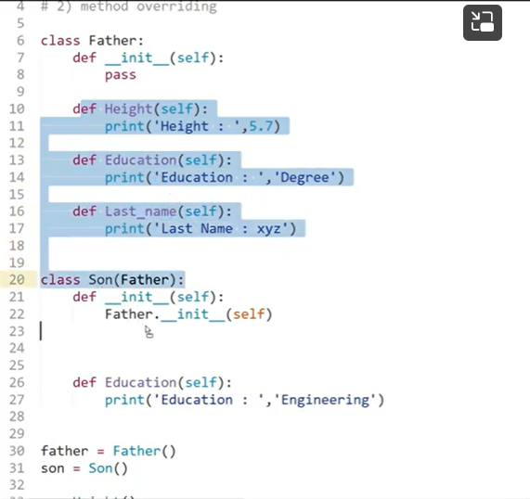

Education override   
should be same method and parameters

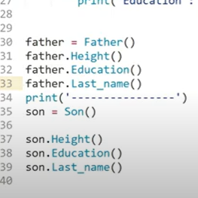

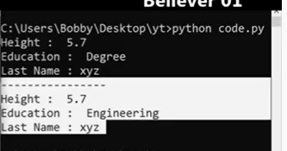

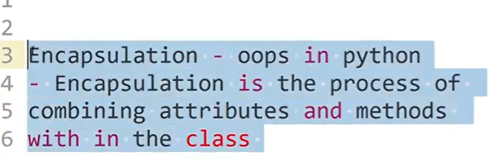

Writing attributes and methods within class

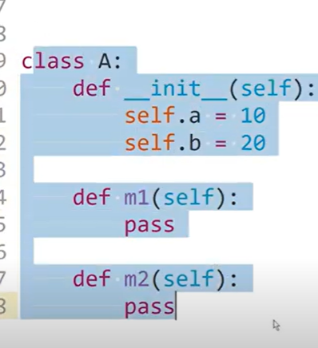

Why ?

Data protection

To make bank balance protected

Data cant be accessed to outside

Otherwise they will change data



Private: only class methods and inside class

Protected: inside class and sub class can be accessed and change

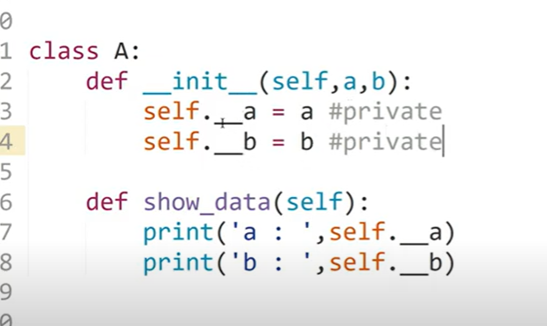

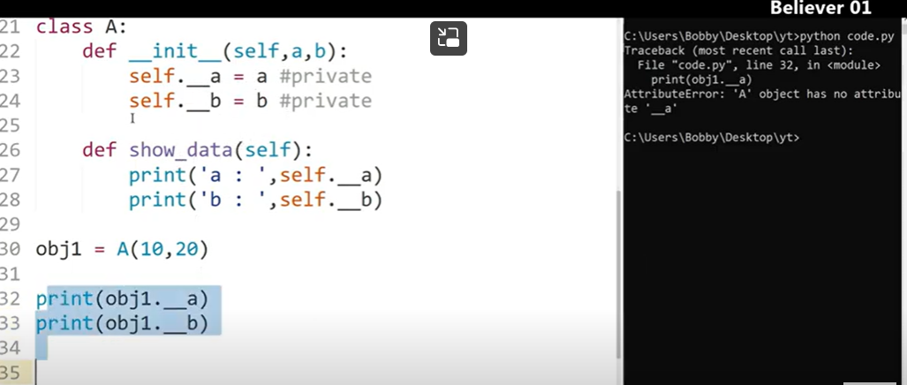

Error because we cant call the private variables outside

But we can access within method



--

Protected

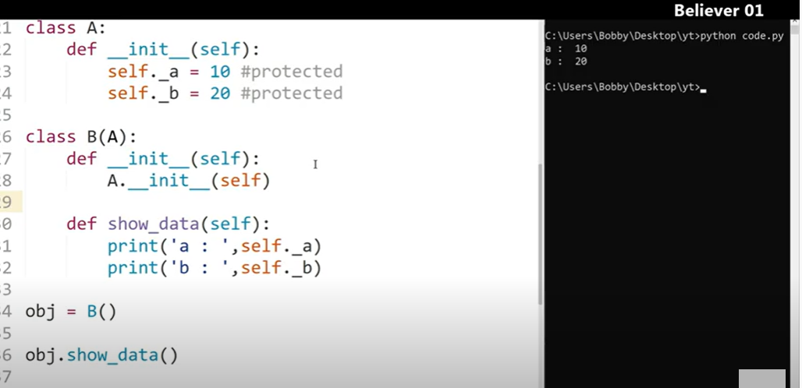

Abstraction:

Abstract class :

With in that we can create sub classes

But we cant create methods inside abstract method

Errors 2 types

1. Compile time
2. Run time: logic wrong, will be handled by exceptional handling

Compile time: while writing code: error in code, compile will check

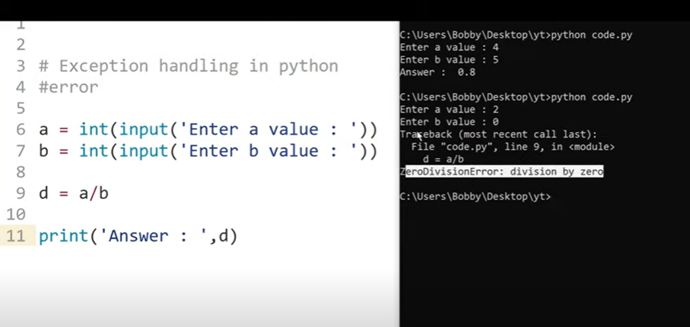

Run time error

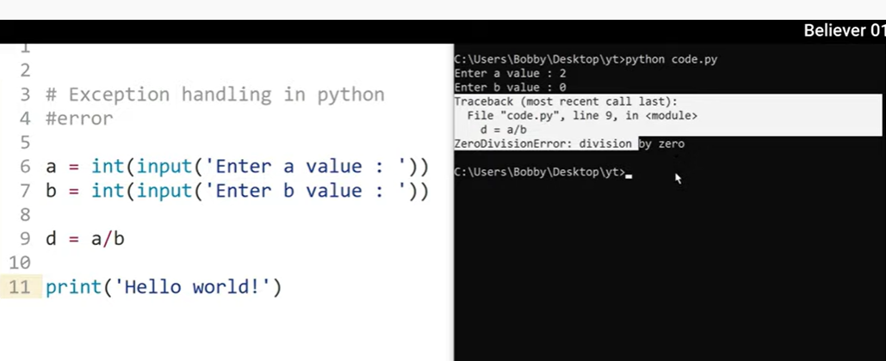

When run time error comes execution will stop there

It wont execute remaining code

* Code which might get error should be placed in try block
* Except: incase error come, we should handle , mesg
* 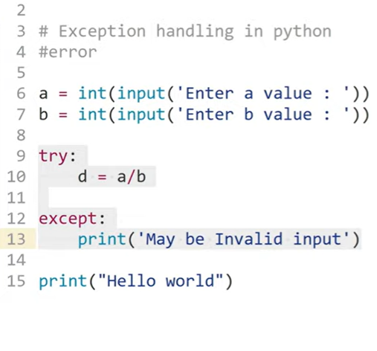
* It wont stop execution of code
* 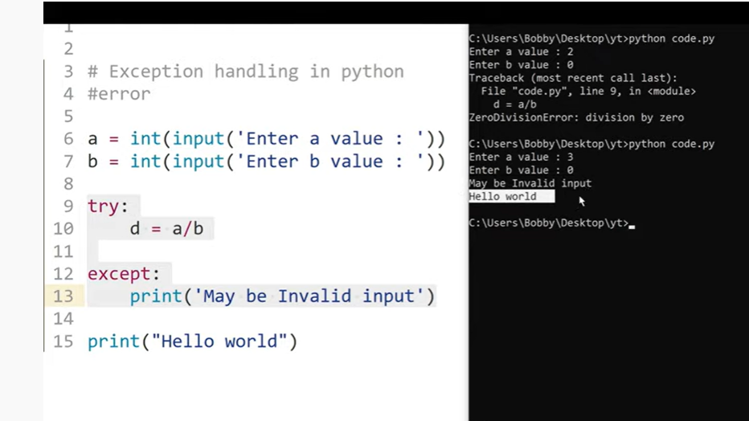
* 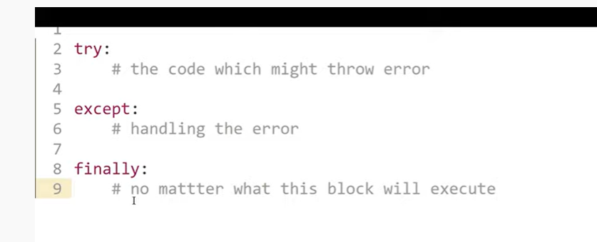
* 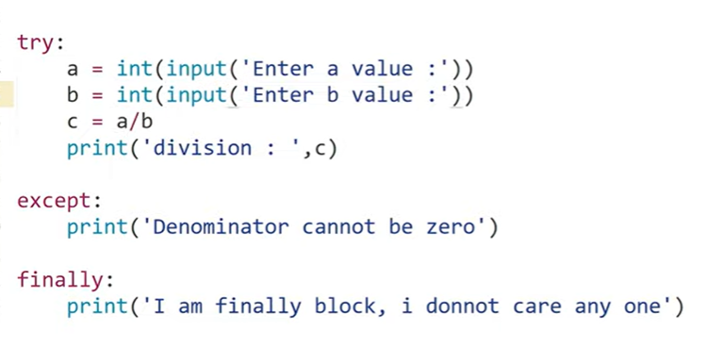
* 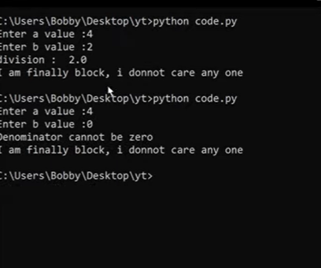
* ---------------------
* ---------------------

Generators:

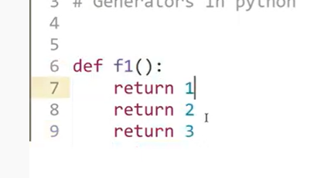

Actually function generate only one return

It stops at one return value

In order to return multiple values we use generators



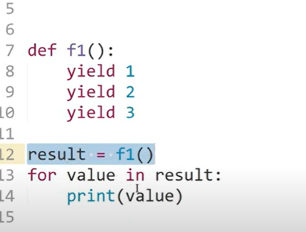

3 yields comes in result

So we use for loop to print result

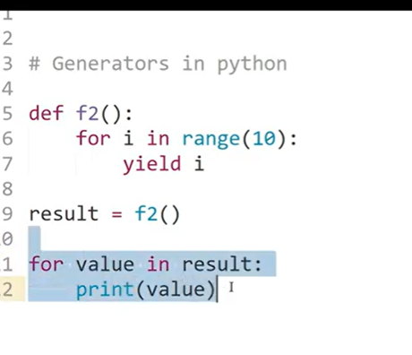

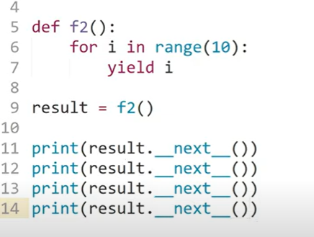

Either we can use for loop

Or next

Generators allows to create our own iterator

No need to define __iter__ and __next__ methods

If we are using one or more yield statements, called as generators

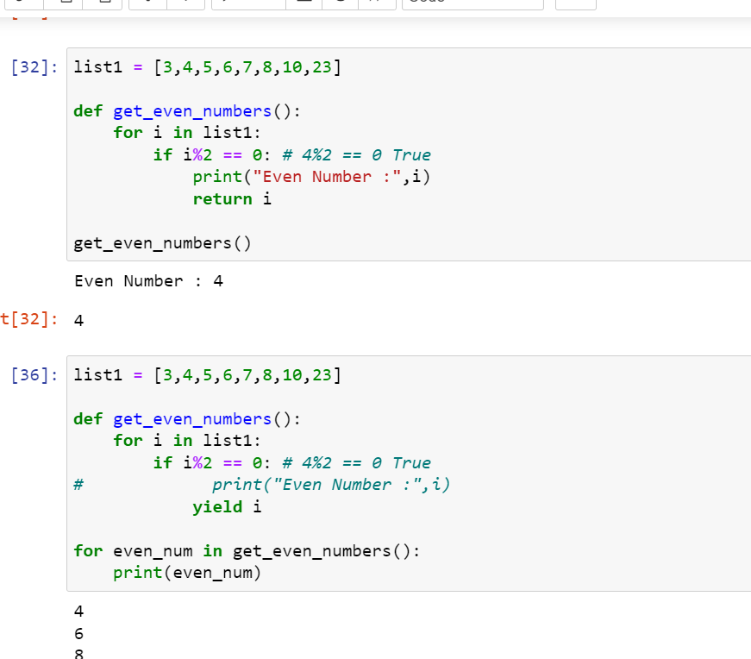

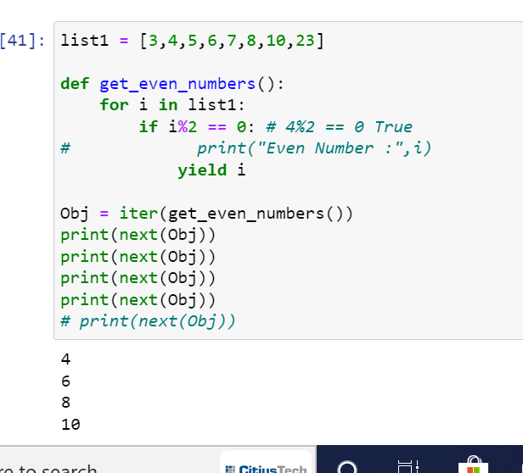

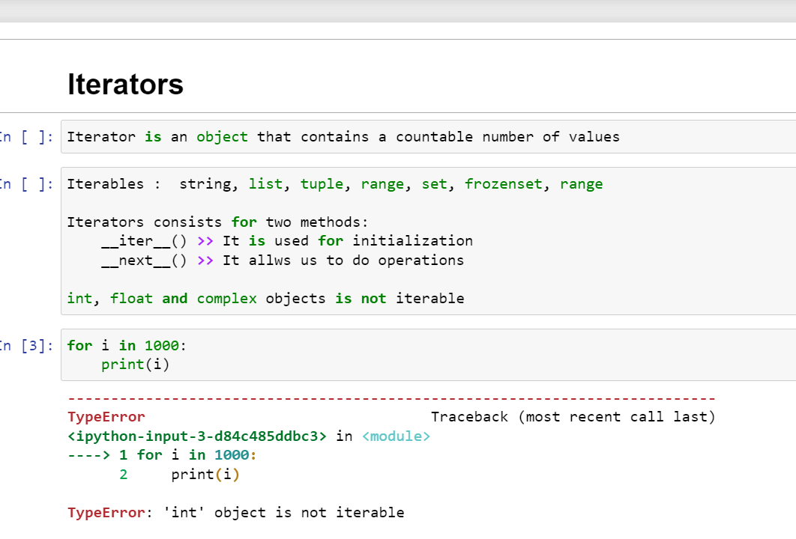

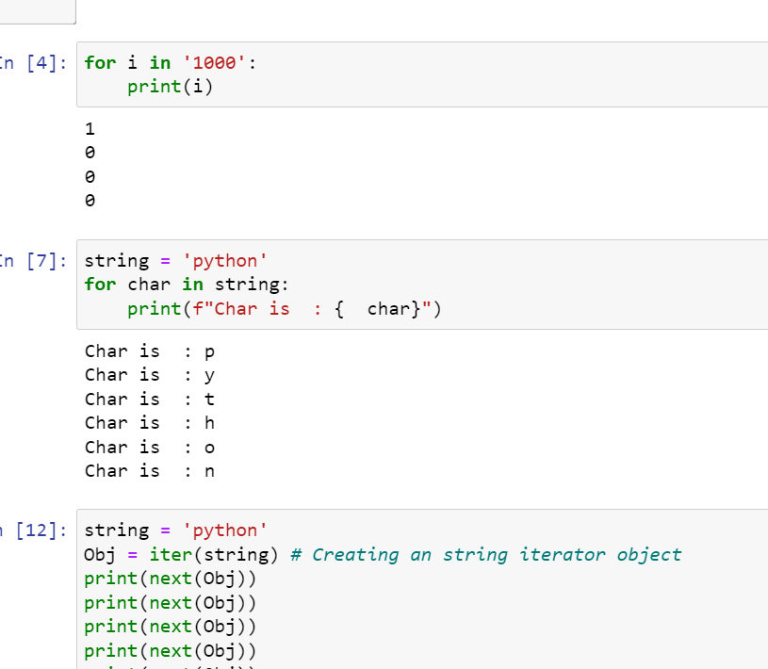

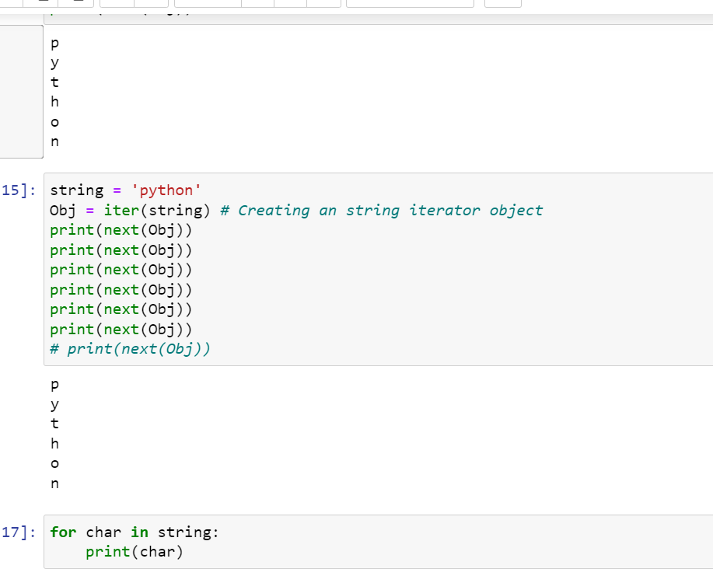

Decorators in python:

It decorates function

If we give any wrong parameters

“0 division error”

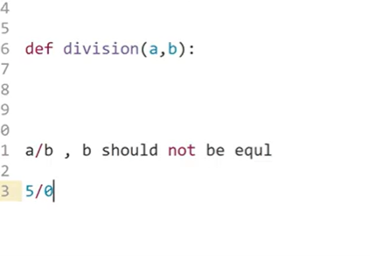

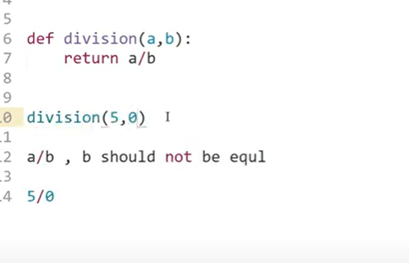

Run time error

We need to handle these kind of situation- we need to decorate them

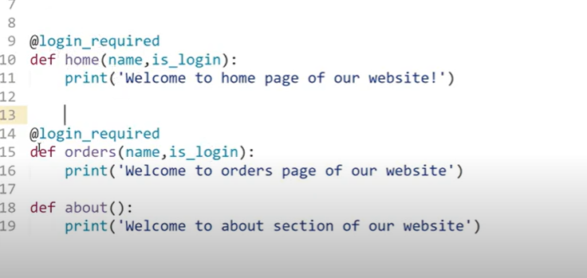

Login required for other function

We need to create **login function now**

**When we use decorators – it sends those functions which required login_required function as parameters o loginrequired function**

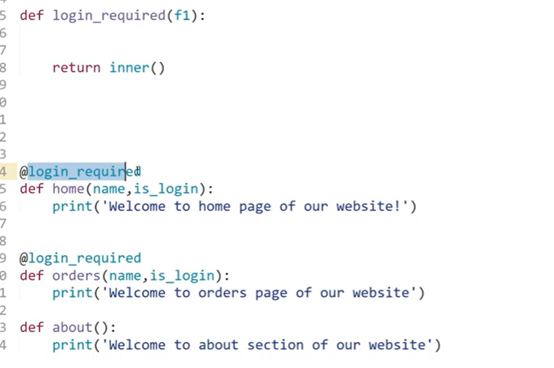

F1 is either home or oder

When ever we call home function, home will be passed as a parameter in loin_required function

--

Now in login_required function will have inner functions : this function should have same parameters of “home “ and Order



